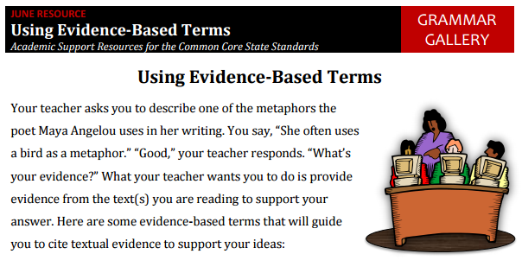
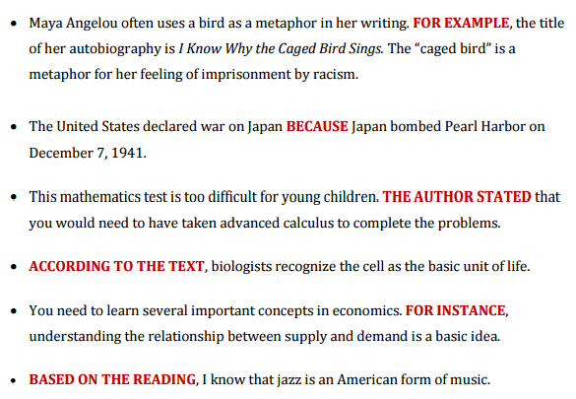

Caged Bird
BY MAYA ANGELOU

A free bird leaps
on the back of the wind
and floats downstream
till the current ends
and dips his wing
in the orange sun rays
and dares to claim the sky.

But a bird that stalks
down his narrow cage
can seldom see through
his bars of rage
his wings are clipped and
his feet are tied
so he opens his throat to sing.

The caged bird sings
with a fearful trill
of things unknown
but longed for still
and his tune is heard
on the distant hill
for the caged bird
sings of freedom.

The free bird thinks of another breeze
and the trade winds soft through the sighing trees
and the fat worms waiting on a dawn bright lawn
and he names the sky his own

But a caged bird stands on the grave of dreams
his shadow shouts on a nightmare scream
his wings are clipped and his feet are tied
so he opens his throat to sing.

The caged bird sings
with a fearful trill
of things unknown
but longed for still
and his tune is heard
on the distant hill
for the caged bird
sings of freedom.

EXTENDED RESPONSE
Use a whiteboard marker to complete the RAER strategy on the following prompt, then respond to the ENTIRE prompt in at least one full paragraph (5-8 sentences) on a blank sheet of notebook paper. Make sure to include your NDP in the top-right corner of your response.

Maya Angelou compares a free bird and a caged bird as a metaphor in the poem, “Cage Bird”. Part A - Use evidence from the poem to describe two ways the free bird and the cage bird are different. Part B - Explain one inference that the reader can make about the birds in this metaphor. Part C - Analyze the text and describe one way the text’s structure contributed to the development of the theme.

